
Visit a Pharmacy For:
- Over-the-counter medications (Tylenol, Ibuprofen, Allergy)
- Cold, flu, and cough remedies
- First aid supplies (band aids, antiseptic)
- Sunscreen and hydration products
- Prescription medication refills (when available)
- Some vaccines and health screenings
Examples:
- Headaches
- Allergies
- Minor cold symptoms
- Upset stomach
- Need a prescription filled
Locations:
- Walgreens
- CVS
- Dillons Pharmacy
- Walmart Pharmacy
- Price Chopper Pharmacy
- Albers Medical Pharmacy
- Spalitto’s Pharmacy
- The Medicine Shoppe
- Hy-Vee Pharmacy
- CenterWell Pharmacy
- Genoa Healthcare
Visit Urgent Care For:
- Minor illnesses and injuries that need same-day treatment
- Sprains and strains
- Minor cuts needing stitches
- Ear infections
- Sore throat or flu symptoms
- Minor burns
- Fever without severe symptoms
- Minor fractures (some places may not offer x-rays)
- Suicide thoughts
Examples:
- Twisted ankle
- Earache
- Persistent cough
- Sore throat
- Minor cut
- Rash
Locations:
- MinuteClinic at CVS
- Saint John Urgent Care
- NextCare
- Heartland Urgent Care
- First Point Urgent
- NKX Health Express Care
- Saint Luke’s Urgent Care
- AdventHealth Centra Care
- CareNow Urgent Care
- Allways Community Health Center

Visit the Health Department For:
- Vaccinations/immunizations
- Travel health information
- Pregnancy and maternal health services
- STI testing and prevention services
- Public health education
- Community health resources
- Naloxone (Narcan) programs and supplies
Examples:
- Need a vaccine
- Looking for pregnancy support services
- Public health information and resources
- Overdose prevention and harm reduction supplies
Locations:
- Leavenworth County Health Department
- Wyandotte County Health Department
- Douglas County Health Department
- Johnson County Health Department
- Platte County Health Department
- Cass County Health Department
- Clay County Health Department
- City of Kansas City Health Department
- Atchison County Health Department
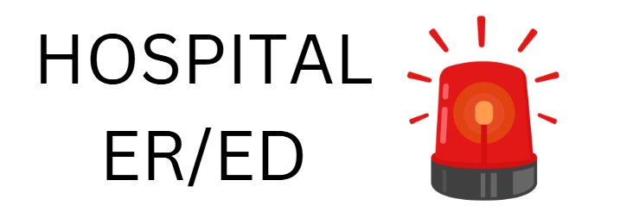Go to the Emergency Room For:
- Chest pain or heart attack symptoms
- Signs of stroke (face drooping, arm weakness, speech difficulty)
- Severe breathing problems
- Major injuries or trauma
- Severe bleeding
- Loss of consciousness
- Seizures
- Serious burns
- Ingestion of drugs
- Someone tried committing suicide
Call 911 Immediately If:
- Someone’s life may be in danger
- Someone is unresponsive
- Someone is not breathing
Locations:
- Saint John Hospital
- Saint Luke’s Community Hospital – Legends
- Providence Medical Center
- Saint Luke’s North – Barry Rd
- NKC Emergency Room
- Overland Park Regional
- University of Kansas Health System – KU Hospital
- AdventHealth – multiple locations across KC Metro
- Amberwell Atchison
- Children’s Mercy – Children’s Hospital
- Shawnee Mission Medical Center
- Research Medical Center
- Menorah Medical Center
- LMH Health
- Olathe Hospital
- ER of independence
- Lee’s Summit Medical Center
- Truman Medical Center – Hospital Hill

